Data Files needed for the Practice:

coach_styles_txt.css, tss_coach_txt.html, 1 CSS file,

5 PNG files, 1 TTF file, 1 WOFF file

Alison has created another page for the Tri and Succeed Sports website providing biographies of the coaches at the club. She has already written the page content, acquired image files, and created a style sheet for the page layout. She wants you to finish the design of the page by developing a style sheet for the page’s color scheme and typography. A preview of the page you’ll design is shown in Figure.

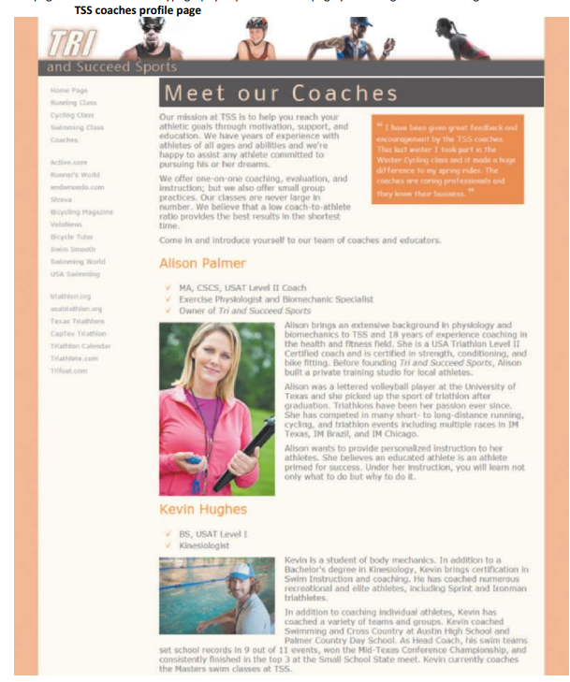

Figure 2-53 TSS coaches profile page

Complete the following:

1. Use your HTML editor to open the tss_coach_txt.html and coach_styles_txt.css files from the review folder. Enter your name and the date in the comment section of each file and save them as tss_coach.html and coach_styles.css respectively.

2. Go to the tss_coach.html file in your editor and then within the document head, create links to the coach_layout.css and coach_styles.css style sheets.

3. Take some time to study the content and structure of the file and then close the document, saving your changes.

4. Go to the coach_styles.css file in your editor. At the top of the file and before the comment section do the following: a. Insert an @charset rule to set the character encoding for the file to utf-8. b. Use the @font-face rule to define a web font named Nobile, which is based on the nobilewebfont.woff file and, if that format is not supported, on the nobile-webfont.ttf file.

5. Go to the Main Structural Styles section and do the following: a. Change the background color of the browser window by creating a style rule for the html element that sets the background color to the value hsl(27, 72%, 72%). b. For the body element, create a style rule to set the text color to the value rgb(91, 91, 91), the background color to ivory, and body text to the font stack: Verdana, Geneva, sans-serif.

6. Create a style rule for the body > footer address selector containing the following styles: a. The background color set to the value rgb(222, 128, 60) b. The font color to white and then to the semitransparent value rgba(255, 255, 255, 0.6) c. The font style to normal displayed in bold small capital letters with a font size of 0.9em and a line height of 3em using the font stack Nobile, Verdana, Geneva, sans-serif d. The text horizontally centered on the page

7. Go to the Heading Styles section and create a style rule for every h1 heading that displays the text with a normal font weight from the font stack: Nobile, Verdana, Geneva, sans-serif. Set the letter spacing to 0.2em and the margin to 0 pixels.

8. Alison wants you to format the main h1 heading at the top of the page. Create a style rule for thesection#tss_coaches h1 selector that sets the font size to 2.5em with a color value of hsl(27, 82%, 85%) and background color of hsl(27, 6%, 21%). Set the left padding space to 10 pixels.

9. Alison also wants you to format the h2 headings for each coach. Create a style rule for the article. coach_bio h2 selector that sets the font size to 1.6em with normal weight and the font color to rgb(240, 125, 0).

10. Alison has inserted a comment from an athlete about the coaches. Format this comment by going to the Blockquote Styles section and creating a style rule for the aside blockquote selector to do the following: a. Set the font size to 0.95em using the font stack ‘Comic Sans MS’, cursive. b. Set the font color to rgb(222, 128, 60) and use a semi-transparent background color with the value rgba(255, 2555, 255, 0.75). c. Set the padding space to 10 pixels. d. Define opening and closing quotes for the element using the Unicode character 201C and 201D respectively.

11. Format the appearance of the opening quotes by creating a style rule for the aside blockquote::before selector to write a boldfaced open quote before the block quote with the font size set to 1.6em from the font stack ‘Times New Roman’, Times, serif.

12. Format the appearance of the closing quotes by creating a style rule for the aside blockquote::after selector to write a boldfaced open quote after the block quote with the font size once again set to 1.6em from the font stack ‘Times New Roman’, Times, serif.

13. Next, you’ll format the appearance of the navigation list by going to the Navigation Styles section and creating a style rule for body > nav selector that sets the text of the navigation list in a 0.8em font size with a line height of 2em.

14. Create a style rule for the nav > ul selector that removes the list marker and sets the left padding to 5 pixels.

15. Alison wants to break up the long list of links in the navigation list. Create style rules for the 6 th and 16th li elements within the nav > ul selector that sets the size of the top margin of those items to 20 pixels.

16. For every previously visited or unvisited hypertext link within the nav > ul > li selector, set the text to the RGB color value rgb(151, 151, 151) and remove the underlining from the text link.

17. For every hovered or active hypertext link within the nav > ul > li selector, set the text color to RGB value rgb(222, 128, 60) and underline the hypertext link.

18. Go to the Paragraph Styles section and insert a style rule that sets the top margin and bottom margin to 10 pixels, the right margin to 30 pixels, and the left margin to 0 pixels for every paragraph in the document.

19. Every coach has a list of accomplishments. Go to the List Styles section and insert a style rule for the article.coach_bio > header > ul selector that displays the check.png file as the list marker and sets the margin space to 0 pixels, except for the bottom margin, which should be set to 10 pixels.

20. Save your changes to the style sheet and then open the tss_coach.html file in your browser. Verify that the color and typography match that shown in Figure. Verify that when you hover the mouse pointer over the links in the navigation list the text is displayed in an underlined orange font.